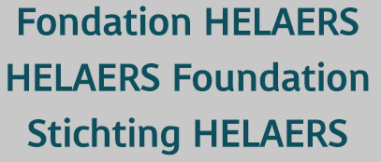

Helaers Research Prize for Stroke
Prix Helaers pour la recherche sur les Accidents Vasculaires Cérébraux (AVC)
Onderzoeksprijs Helaers voor Beroertes

Application form 2022

The application form must be submitted in English. All section should be duly completed, failing which the application shall be discarded. The application file shall not be returned to the applicant.

The application form must be received in paper and electronic format at the latest on May 31th.

The application form must be sent by email at the following addresses:
- To Prof Peter VANACKER, President of the Belgian Stroke Council
- Email : peter.vanacker@uza.be
- To Ms. Nicole BRAEKMAN, President, Fondation Helaers
Email: fondation.helaers@skynet.be
1. Overview detailing the Project (of 2 pages maximum), highlighting that the conditions set out above in the article are fulfilled together with a translation of the overview in French or Dutch at the choice of the applicant

2. Detailed description of the project (maximum word count 2500, not including references)

3. Detailed resume of the Researcher, including affiliation and e-mail address

4. List of his publications, highlighting that the conditions set out in Article 3 are fulfilled

5. Description of the Researcher’s integration in the Belgian academic, scientific or clinical community.

6. A copy of any additional document (publications, sponsorship letter, any other document of major importance) can be enclosed to the application. It is strongly advised to enclose with the application form attestations and support letters. Although these documents are not compulsory, they can inform the deliberations of the Jury concerning the granting of the Prize. Such documents must be part of the application file.

